Assignment No.

TITLE: Generation of square waveform and Pole-Zero Diagram
Aim:
Write a C++/ Python program to generate a Square wave of programmable frequency. Write a function to generate Pole-Zero Diagram using multicore programming.
Objective:
1. Generation of Square wave of programmable frequency.
2. Generate Pole-Zero Diagram using multi core Programming.
Theory:
Square Wave:
A square wave is a non-sinusoidal periodic waveform, in which the amplitude alternates at a steady frequency between fixed minimum and maximum values, with the same duration at minimum and maximum. The transition between minimum to maximum is instantaneous for an ideal square wave. Square waves are often encountered in electronics and signal processing.
Square waves are universally encountered in digital switching circuits and are naturally generated by binary (two-level) logic devices. They are used as timing references or "clock signals", because their fast transitions are suitable for triggering synchronous logic circuits at precisely determined intervals.
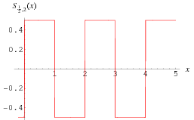
Fig.1 square wave form.6655

Pole Zero Plot:
A pole–zero plots is a graphical representation of a rational system function H(z) in the complex plane which helps to convey certain properties of the system such as:
- Stability
- Causal system / anticausal system
- Region of convergence (ROC)
A pole-zero plots shows the location of the poles and zeros of the system function of a dynamic system, such as a controller, compensator, sensor, equalizer, filter, or communications channel in the complex plane. By convention, the poles of the system are indicated in the plot by an X while the zeroes are indicated by a circle or O.
Discrete Time System:
In general, a rational transfer function for a discrete-time LTI system has the form:
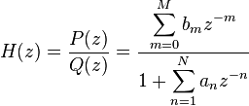
Where
- is the order of the numerator polynomial,
- is the m-th coefficient of the numerator polynomial,
- is the order of the denominator polynomial, and
- is the n-th coefficient of the denominator polynomial
Either M or N or both may be zero.
Poles and zeros:
- such that are the zeros of the system
- such that are the poles of the system.
Example:
If and are completely factored, their solution can be easily plotted in the z-plane. For example, given the following transfer function:
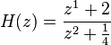
The only (finite) zero is located at: , and the two poles are located at: 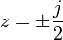, where j is the imaginary unit.

The pole–zero plot would be:
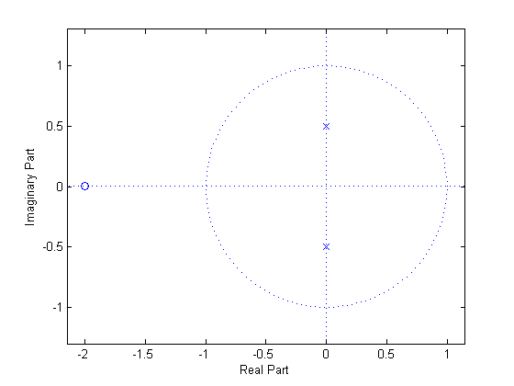
Fig.2 Pole zero plot

Python or C++ Programming (should be written by students)
Depending on whichever language you have used write about theory of multi-core programming.
Multi core programming:

Algorithm: (should be written by students)

- Write algorithm for generation of square waveform.
- Write algorithm for pole zero diagram using multi-core programming.

Square wave generation
Input: Frequency of the waveform.
Output: Square waveform generated graphically on the monitor with the given frequency.

Pole-Zero Plot
Input: Coefficients of numerator and denominator polynomials of system function.
Output: Pole-zero plot.

Conclusion: Thus, we have successfully generated the square waveform and pole zero plot for given system function.

Mathematical Model: (Should be written by students)

FAQs:
1. What do you mean by ROC?
2. Define system function.
3. How to find type of system using ROCs?(e.g. Causal, noncausal, stable, unstable)
4. Explain all the functions which are directly used from python library or any C++ library
used in the program.

